**DevOps Project 4**

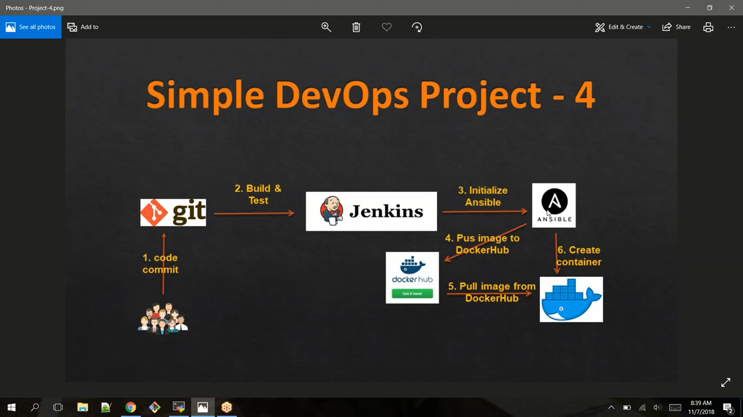

**Part-01 : Create an docker image**

1. Login to Jenkins console
2. Create *Jenkins job-Devops_projec_t 4*, Fill the following details,

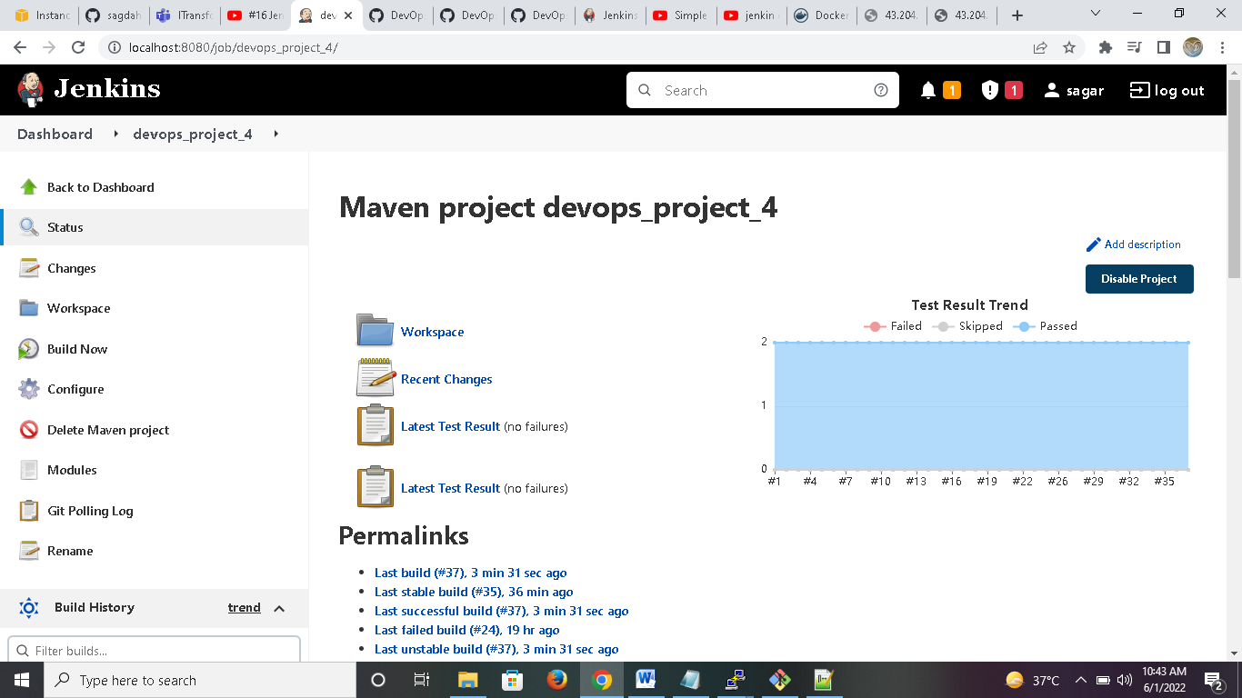

* + *Source Code Management:*
    - Repository : https://github.com/sagdahiy/devops4.git
    - Branches to build : */master

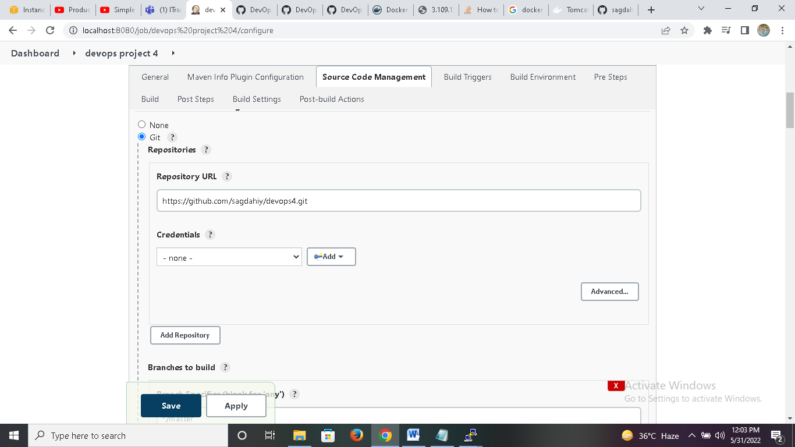

* + *Build:*
    - Root POM:pom.xml
    - Goals and options : clean install package

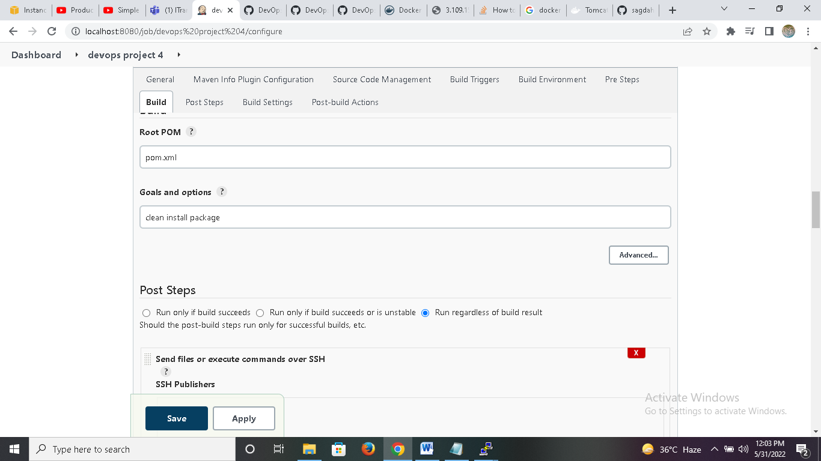

* + *Post Steps*
    - *Send files or execute commands over SSH*
      * Name: ansible2
      * Source files : webapp/target/*.war
      * Remove prefix : webapp/target
      * Remote directory : //opt//docker

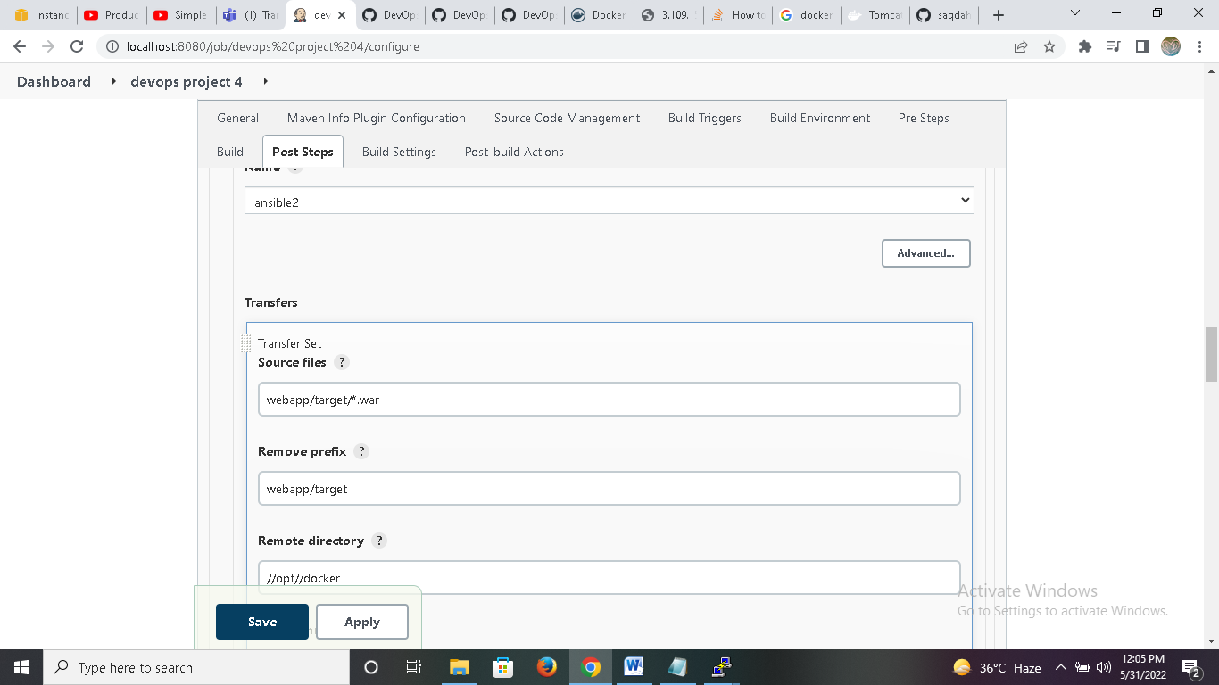

* + - *Send files or execute commands over SSH*
      * Name: ansible2
      * Source files : Dockerfile
      * Remote directory : //opt//docker
      * Exec Command:
        + cd /opt/docker
        + docker build -t sagar .
        + docker tag sagar smartysd/sagar
        + docker push smartysd/sagar
        + docker rmi sagar smartysd/sagar

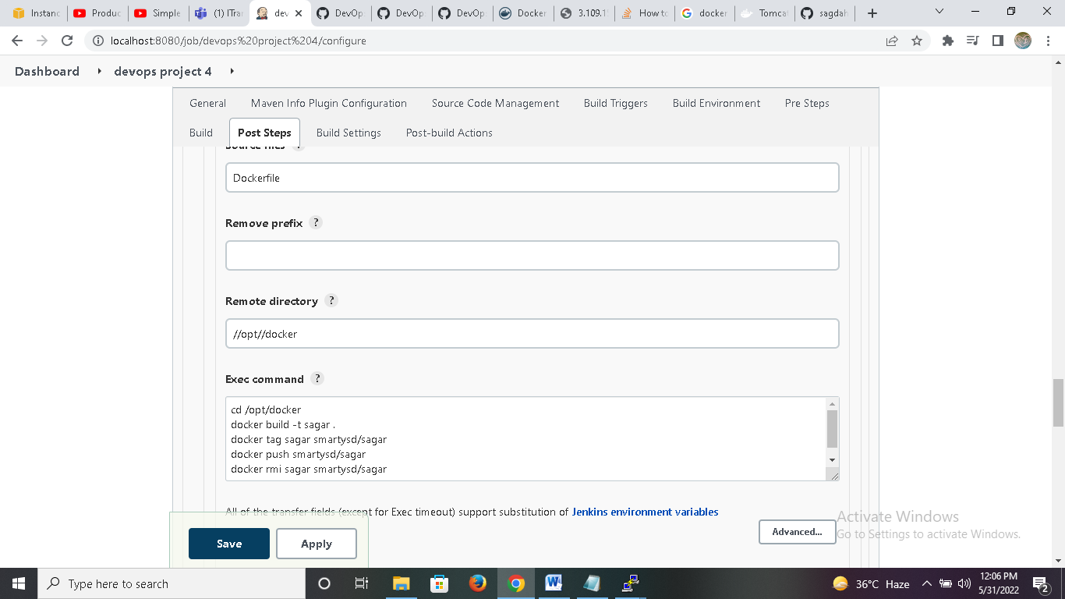

1. Login to Docker host and check images and containers. (no images and containers).

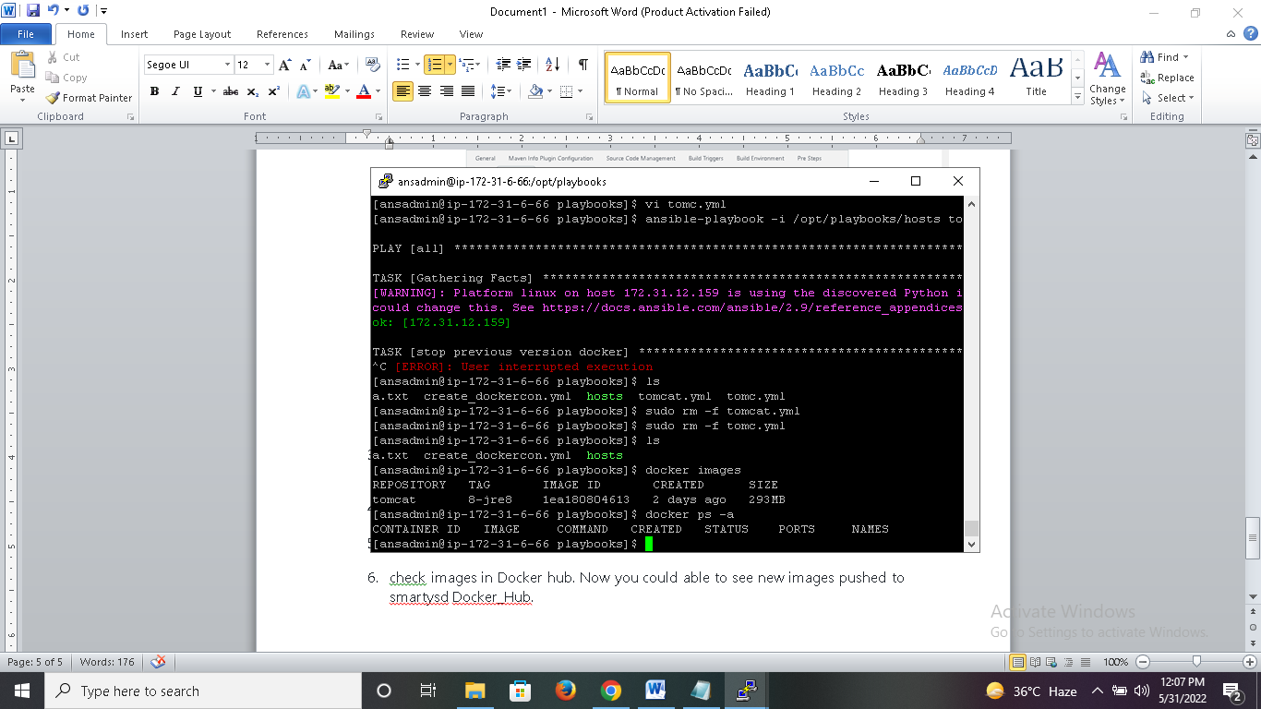

1. login to docker hub and check. shouldn't find images with for smartysd/sagar.
2. Execute Jenkins job.

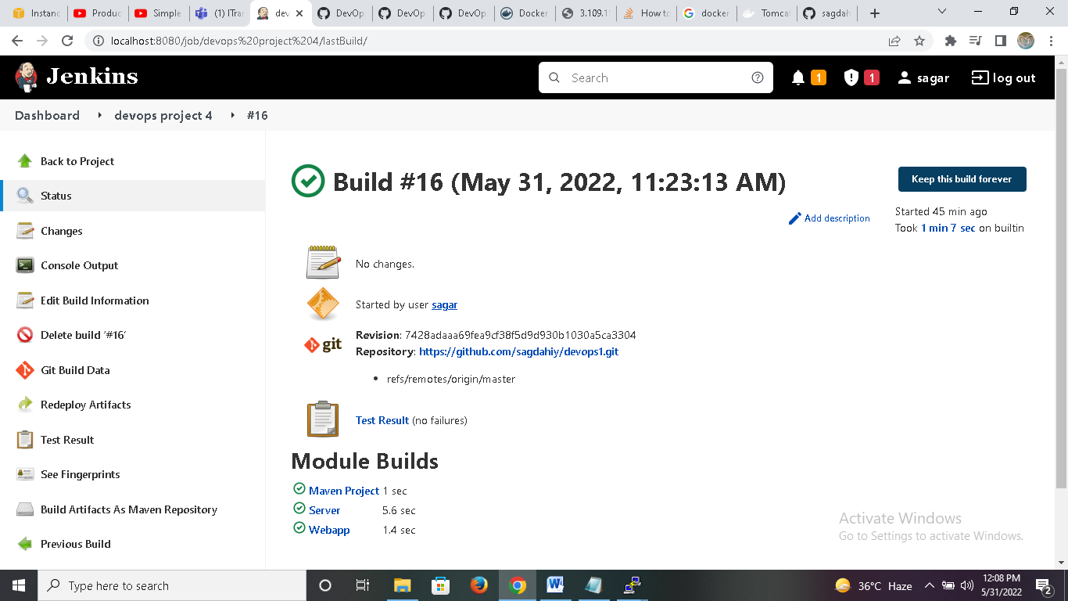

1. check images in Docker hub. Now you could able to see new images pushed to smartysd Docker_Hub.

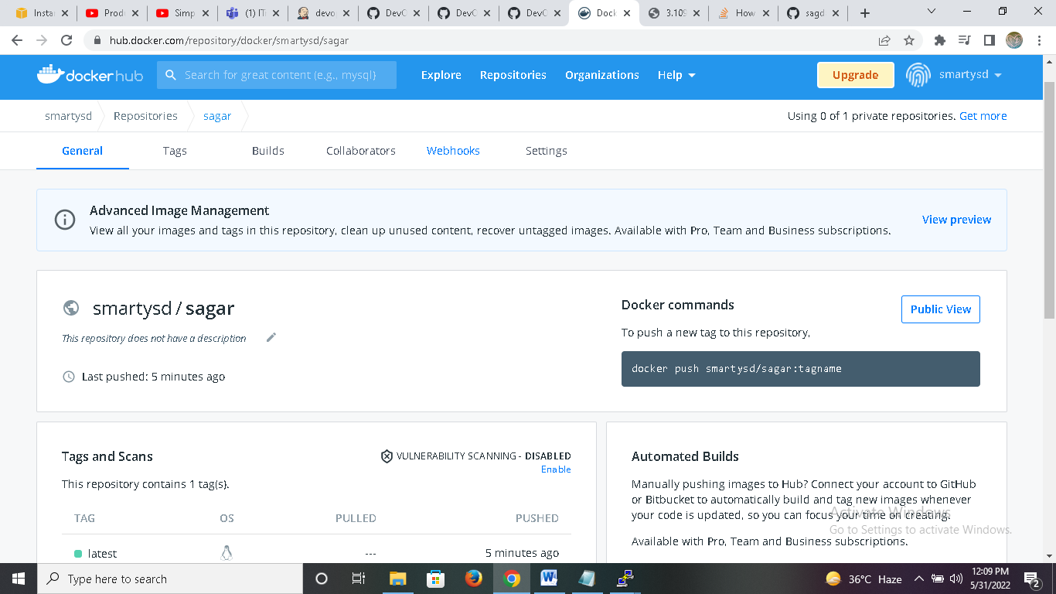

**Part-02 : Deploy Containers**

1. Write a yml file to create a container (file name : create_docker_container.yml)

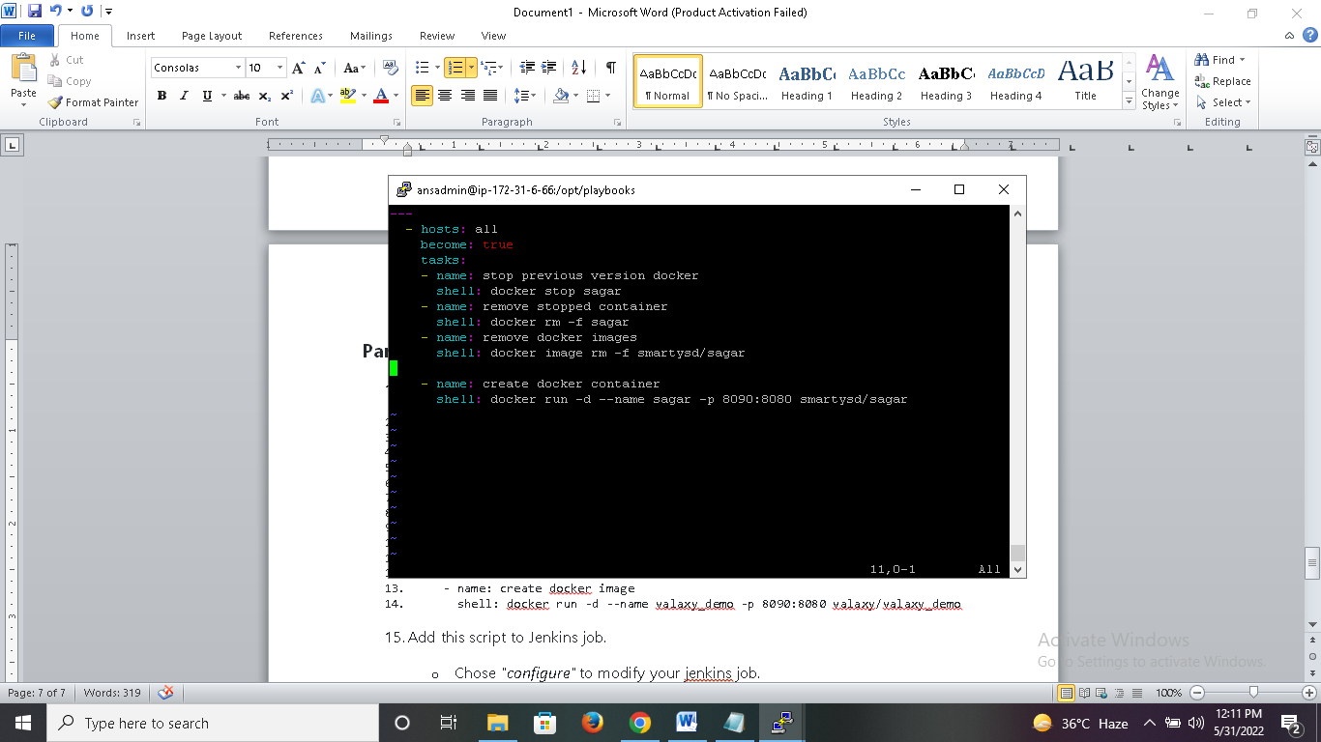

1. ---
2. - hosts: all
3. become: true
4. tasks:
5. - name: stop previous version docker
6. shell: docker stop sagar
7. - name: remove stopped container
8. shell: docker rm -f sagar
9. - name: remove docker images
10. shell: docker image rm -f smartysd/sagar
11. - name: create docker container
12. shell: docker run -d --name sagar -p 8090:8080 smartysd/sagar
13. Add this script to Jenkins job.
    * **Chose *"configure"* to modify your jenkins job.**
      + ***Under post build actions***
        - **Send files or execute commands over SSH**
          * **Exec Command:**
        - **cd /opt/playbooks**

**ansible-playbook create_dockercon.yml**

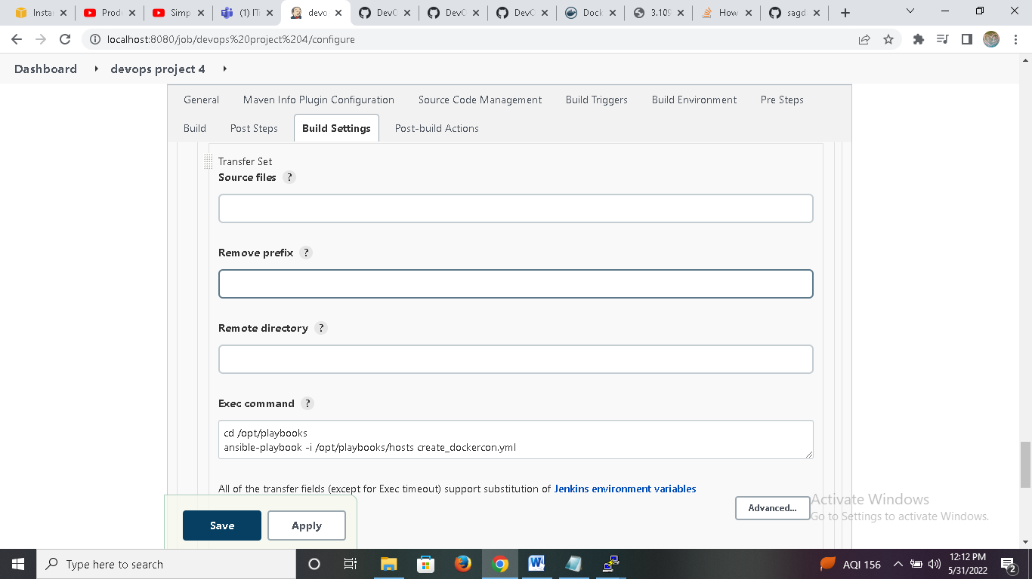

1. Execute Jenkins job.
2. You could see a new container on your docker host. can able access it from browser on port 8090

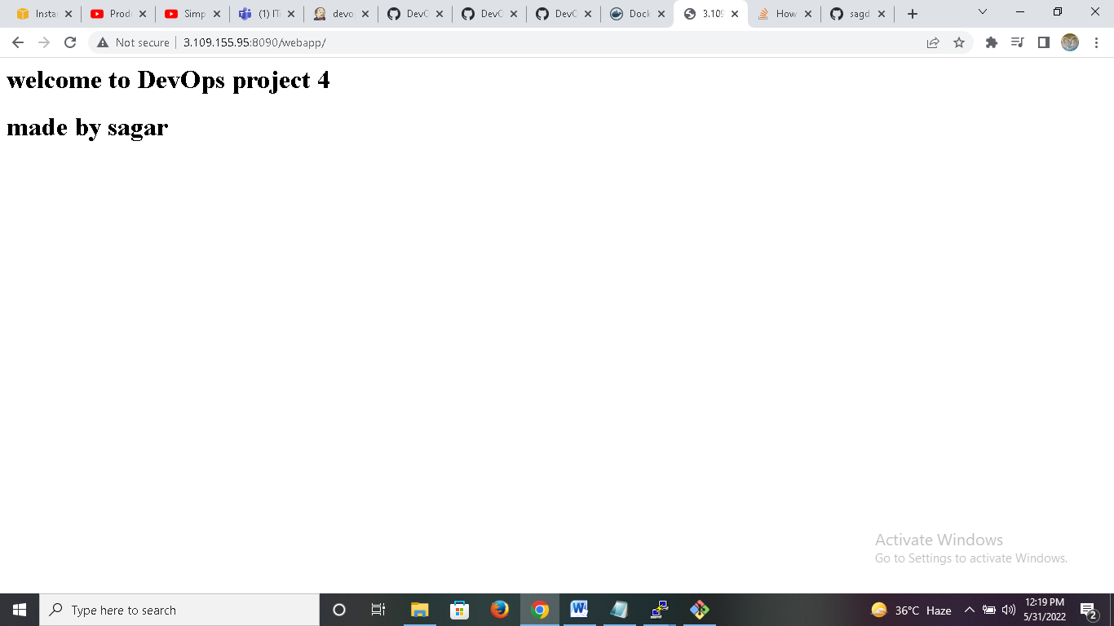

**Part-03 : Deploy with Version Control Containers**

So for we used latest docker image to build a container, but what happens if latest version is not working?  
One easiest solution is, maintaining version for each build. This can be achieved by using environment variables.

here we use 2 variables

* BUILD_ID - The current build id
* JOB_NAME - Name of the project of this build. This is the name you gave your job when you first set it up.

Lets modify jenkins job which was created in *Part-01* as below.

1. Create Jenkins job
   * *Source Code Management:*
     + Repository : https://github.com/sagdahiy/devops4.git
     + Branches to build : */master
   * *Build:*
     + Root POM:pom.xml
     + Goals and options : clean install package
   * *Send files or execute commands over SSH*
     + Name: ansible_server
     + Source files : webapp/target/*.war
     + Remove prefix : webapp/target
     + Remote directory : //opt//docker
   * *Send files or execute commands over SSH*
     + Name: ansible_server
     + Source files : Dockerfile
     + Remote directory : //opt//docker
       - cd /opt/docker

* docker build -t $JOB_NAME:v1.$BUILD_ID .
* docker tag $JOB_NAME:v1.$BUILD_ID smartysd/$JOB_NAME:v1.$BUILD_ID
* docker tag $JOB_NAME:v1.$BUILD_ID smartysd/$JOB_NAME:latest
* docker push smartysd/$JOB_NAME:v1.$BUILD_ID
* docker push smartysd/$JOB_NAME:latest
* docker rmi $JOB_NAME:v1.$BUILD_ID smartysd/$JOB_NAME:v1.$BUILD_ID
* smartysd/$JOB_NAME:latest

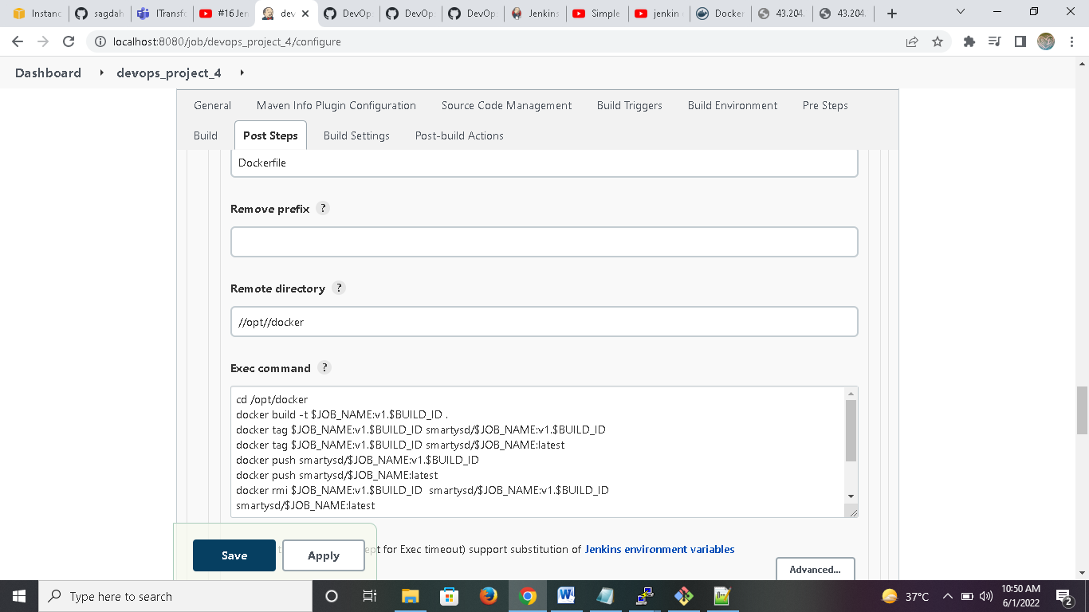

* Now build this jenkins job again.
* You can check images and containers created in docker server

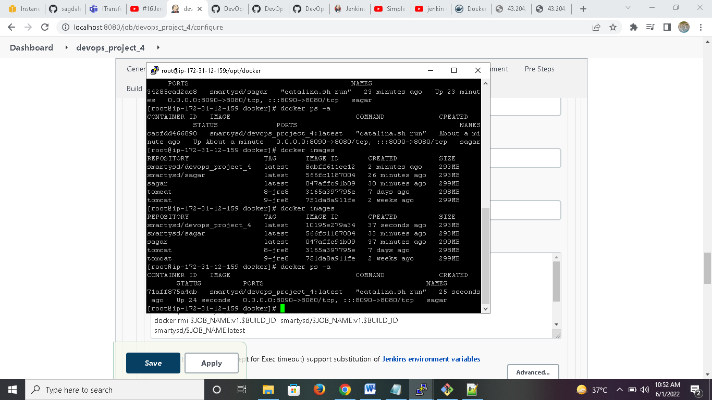

* Also you can check images created in docker hub.

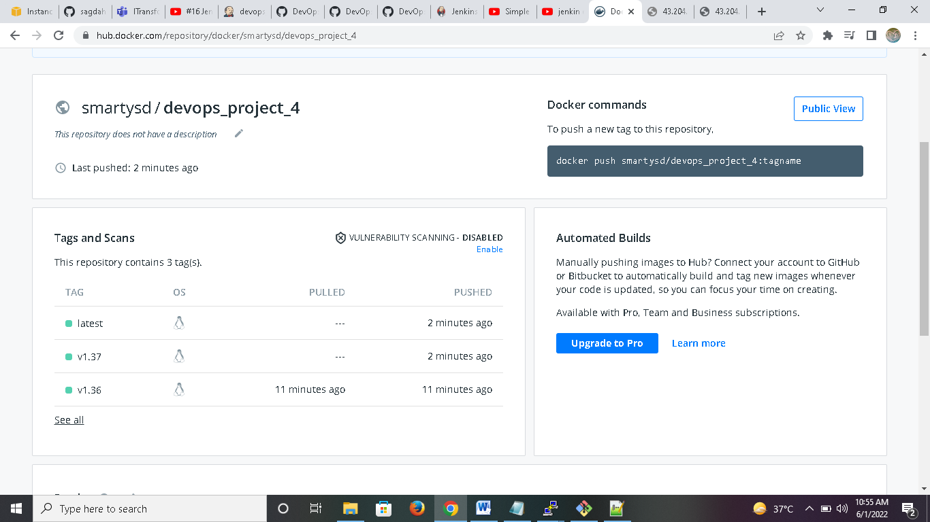

* Also make some changes in code.

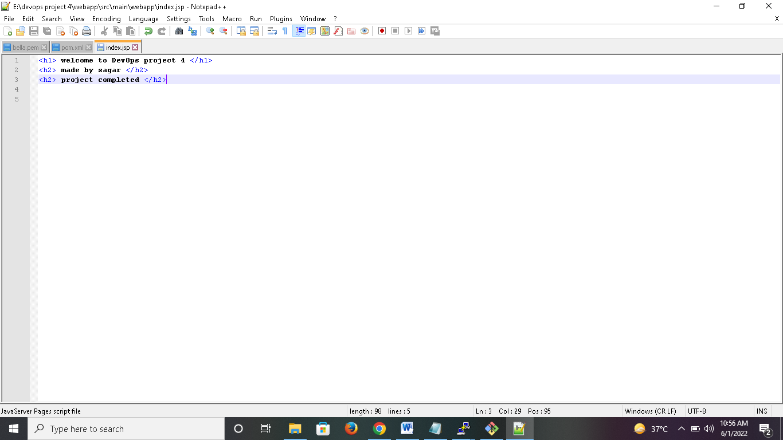

* Now you can check updated version of project in web browser.

